Limited Prep – Draw Procedures
ALL students entered in EXT will perform draw via SpeechWire even if they choose to prep their speech in the in-person prep room. No paper topic slips will be provided in-person. Please familiarize yourself with the following procedures and polices regarding draw an prep.
Prep Room Options
On-site Prep Room: Plaster Student Union Ballroom West
Virtual Prep Room: https://ucincinnati.zoom.us/j/8057333763
**Please mute yourself when entering the virtual draw space and remain on mute unless you need to communicate directly with Tournament Staff**
Tournament staff will make the announcement for speakers in both spaces when it is their time to draw.
Double Entry Bumps
Tournament Staff have been provided a list of all students double entered in Extemp and Broadcast Journalism have made the necessary adjustments to the draw order so there is no need to alert them of your status as Double Entered.
SpeechWire Accounts
To access draw via SpeechWire all students much have individual accounts. Coaches, make sure all competitors have SpeechWire accounts – these should be created by the coach and not independently by the student in the SpeechWire system.

View the step-by-step video here: Click on Student Accounts video.
https://www.speechwire.com/p-video-resources.php
Also provided is a pdf:
https://www.speechwire.com/handbooks/registrationhandbook.pdf
Electronic Draw Instructions
- Enter either the in-person or virtual prep room at the assigned start time for Draw.
- Wait for your name to be called by the tournament staff – after all speakers at the designated speaker position are accounted for the draw manager will open draw for you.
- From your SpeechWire account click “Pi Kappa Delta – Biennial Tournament and Convention” and then “Click here to enter draw”
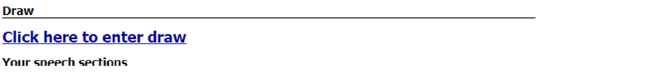
- You will then see any available topic draws listed for you. Select “Click here to draw now” for the corresponding round.
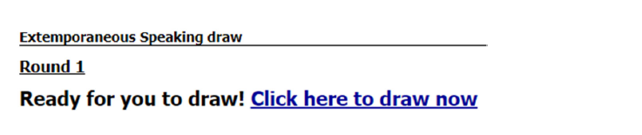
- For Extemp: select your question from the list provided. *You must CLICK your selected prompt*
- For Broadcast Journalism: You will be provided a list of three topic areas such as “Central America, the US Congress and Climate Change.” While other stories can be included to make time, judging criteria will favor those identified in the round’s prompt.
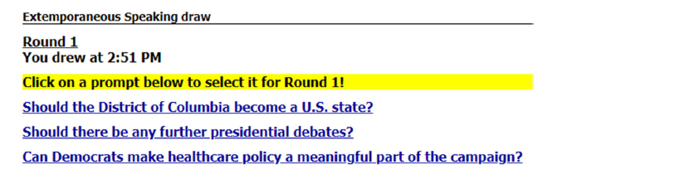

Debate Policies and Procedures
NPDA DRAW
Prep Room Options
On-site Prep Room: Plaster Student Union Ballroom West
Virtual Prep Room: https://ucincinnati.zoom.us/j/8057333763
**Please mute yourself when entering the virtual draw space and remain on mute unless you need to communicate directly with Tournament Staff**
Preliminary Round Draw Procedures
- 5 minutes prior to the start of Draw members of the Tournament Staff will conduct a roll call to see which teams are present; because many teams choose to prep in a different space and send only a representative to draw a team will be considered present if any member of their team responds to the roll call. We will not wait until all members of a team are physically present to proceed with draw.
- Tournament staff will wait no longer than 5 minutes past the established draw time to complete roll call and announce the topic.
- The topic will be announced in the room and streamed virtually at https://ucincinnati.zoom.us/j/8057333763
- Please mute yourself when entering the virtual draw space and remain on mute unless you need to communicate directly with Tournament Staff
- After the topic is released it will also be posted here along with a time stamp of when the topic was announced for future reference:
  - https://docs.google.com/document/d/1n2rbCFf1OOxc6_CTl6RzUtPbJ1kXe2DKdqq-7hCvrsQ/edit?usp=sharing
Elimination Round Draw Procedures
- 5 minutes prior to the start of Draw members of the Tournament Staff will conduct a roll call to see which teams are present; because many teams choose to prep in a different space and send only a representative to draw a team will be considered present if any member of their team responds to the roll call.
- Once both teams in a given round are present, Tournament Staff will conduct the flip for sides if opponents have not met previously in competition.
- Tournament staff will wait no longer than 10 minutes past the established draw time to complete roll call and announce the topic.
- The topic will be announced in the room and streamed virtually at https://ucincinnati.zoom.us/j/8057333763
  - After the topic is released it will also be posted here along with a time stamp of when the topic was announced for future reference:
    - https://docs.google.com/document/d/1n2rbCFf1OOxc6_CTl6RzUtPbJ1kXe2DKdqq-7hCvrsQ/edit?usp=sharing

IPDA DRAW
On-site Draw Room: Plaster Student Union Ballroom West
Preliminary Round Draw Procedures
- 10 minutes prior to the start of Draw members of the Tournament Staff will ask students to line up under the designated section number along the wall to facilitate the strike process.
- At the start of draw pairings will be given their topic slip to begin the strike process.
  - If one of the competitors is missing, the competitor in attendance will be asked to wait no longer than 5 minutes to choose a topic. If at the end of the 5 minute waiting period, the second competitor has still not arrived the competitor in attendance will inform the Tournament Staff of their selected topic and the start of prep time will be denoted.
  - The late arriving competitor should check-in with Tournament staff upon arrival to receive their topic and determine the amount of prep time remaining.
- We are utilizing flighted rounds so make sure that you arrive for draw at the specified time for your flight.
Elimination Round Draw Procedures
- 10 minutes prior to the start of Draw members of the Tournament Staff will ask students to line up under the designated section number along the wall to facilitate the strike process.
- Once both teams in a given round are present, Tournament Staff will conduct the flip for sides.
- At the start of draw pairings will be given their topic slip to begin the strike process.
  - If one of the competitors is missing, the competitor in attendance will be asked to wait no longer than 5 minutes to choose a topic. If at the end of the 5 minute waiting period, the second competitor has still not arrived the competitor in attendance will inform the Tournament Staff of their selected topic and the start of prep time will be denoted.
  - The late arriving competitor should check-in with Tournament staff upon arrival to receive their topic and determine the amount of prep time remaining.

IMPORTANT NOTE: If you or your partner are double entered in PF/LD it is your responsibility to arrive at draw on time. Please inform the judges/competitor in the other event that you need to leave promptly after the debate to make it to your next round and ask a teammate or coach to stay for oral critiques should they run long.
FORFEIT PROCEDURE IN DEBATE
NPDA
- ALL debates are expected to begin no later than 40 minutes after the topic is announced. This provides for 20 minutes of prep time and ample walk time to the room.
- Judges will be permitted to issue a forfeit to teams arriving after the 40 minute mark. Official start times are logged by the draw staff.
IPDA
- ALL debates are expected to begin no later than 40 minutes after the scheduled draw time. This provides ample time for topic strike, prep, and walk time to the room.
- Judges will be permitted to issue a forfeit to students arriving after the 40 minute mark. Official start times are logged by the draw staff.

